READING

1 - Which of the skills in the box are important for these jobs? Choose the two most important skills for each job.

analytical - communication skills - hard-working - IT skills –
language skills - motivated - organised - team worker

• Digital Designer: _____________________________________________________
• Translator: _____________________________________________________
• Project Manager: _____________________________________________________
• Sales Assistant: _____________________________________________________
• Finance Officer: _____________________________________________________
• Small Business Owner: _____________________________________________________

2 - Read the three job advertisements (A–C). Match them to three jobs in Exercise 1.

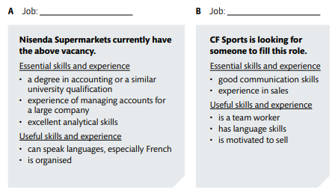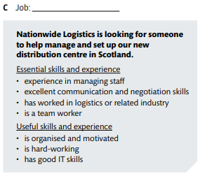

3 - Reread the ads and answer the following question:

- What is a common requirement for the 3 (three) jobs?
________________________________________________________________________________________________________________________________________________________________

4 - Complete with Nisenda Supermarkets (NS), CF Sports (CFS) or NL (Nationwide Logistics). In some cases, more than one answer may be possible.

- _________ requires a university degree.
- _________ requires team working skills.
- _________ requires organizational skills.
- _________ considers IT skills are important.
- _________ requires motivation.
- _________ requires communication skills.
- _________ requires to be a hard-working employee.

USE OF ENGLISH

The best person for the job
5 - Complete the questions with the words in the box.

candidates – choose – degree – languages – qualifications – essential – vacancies

- What are the best __________________ for the job?
- Who will we __________________ for the job?
- Which __________________ have worked in other countries?
- What type of university __________________ do you need for this job?
- How many __________________ are there in your department?
- Which __________________ are useful for this job?
- Is it __________________ to have previous work experience? Yes, it´s necessary.

PRESENT PERFECT
6 Choose the correct option, a or b.
1 I have ______ travelled to the company’s headquarters in Munich. Have you?
a) ever b) never
2 Has she ______ in the tourism industry?
a) been b) went
3 She ______ on some international projects. She went to Japan and India last year.
a) hasn´t worked b) has worked
4 ______ much experience with meetings in English?
a) Have you had b) Haven’t you have
5 Which companies has she ______ for?
a) works b) worked
6 Patrick and I haven’t ______ to the client recently.
a) spoken b) spoke
7 Has he ______ presentations in English?
a) gave b) given
8 ______ used this software program?
a) They have never b) Have they ever
9 He ______ studied abroad.
a) hasn’t b) haven’t
10 Tom and Lisa have ______ many sales reports.
a) written b) write

7 - Complete the sentences with the correct verb form for talking about experiences

- Fumiko _________________ (never use) this software program.
- Nadia and Kim _________________ (not work) together before.
- Will _________________ (study) in the USA.
- Ulla _________________ (write) three reports this month.
- I _________________ (manage) my own company for many years.
- Marcos _________________ (not travel) for work this year.

8 – Choose the correct answer.

- Eugenio gave / has given many presentations of different products. He gave / has given the last one on Thursday.
- Katie has never had / never had a job interview. This is her first one.
- I've been / I went to Australia on business last summer. It was amazing.
- Charlie and I worked / have worked on many projects. The most difficult was / has been the printing project in February last year.
- Kamal has visited / visited many factories in Africa but he hasn't been to any in Asia.
- We opened / We've opened a new restaurant last year. Not many people came up first.

WRITING
9 – Imagine you are Anna Thompson. Use the information below and write a professional profile.




